DAILY ASSESSMENT FORMAT

|  |  |  |  |
| --- | --- | --- | --- |
| Date: | 19 MAY 2020 | Name: | Preetham |
| Course: | TCS ION CAREER EDGE | USN: | 4AL18EC040 |
| Topic: | DAY 4:gain guidance from career gurus  DAY 5:write a winning resume and cover letter  DAY 6:stay ahead in group discussion | Semester & Section: | 4TH SEM  & A SEC |
| Github  Repository: | Psraipreetham |  |  |

|  |  |
| --- | --- |
|  | FORENOON SESSION DETAILS |
| Image of session |  |

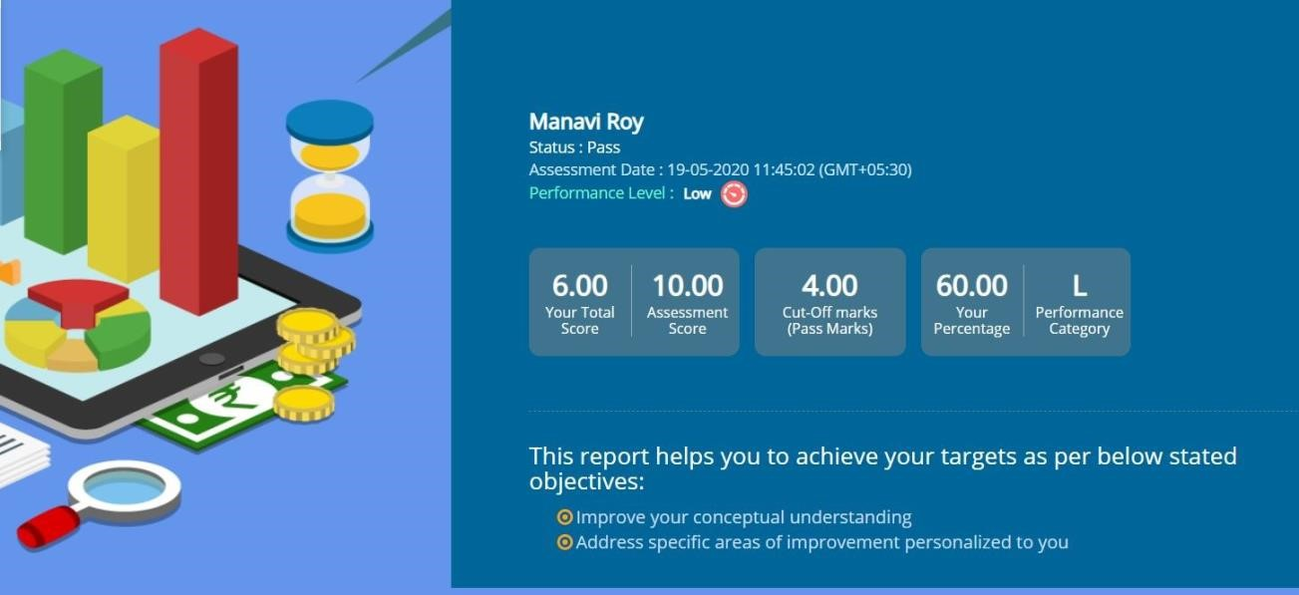

|  |  |  |  |  |  |
| --- | --- | --- | --- | --- | --- |
| Report – Report can be typed or hand written for up to two pages.    TO PREPARE STRONG RESUME AND COVER LETTER :-     * The resume shoould be crisp and on to the point. * The resume should be clear about your career objectives. * Choose the formal/style that is best suited for the profile. * Do not lie in the resume.       PREPARE FOR THE GROUP DISCUSSION:-     * a group discussion is not a debate. * To be aware of your body language. * To keep a check on your tone of voice and language. ● To update your self with current information ● Not to panic. ● To maintain a formal decorum. | | | | | |
| |  |  |  |  | | --- | --- | --- | --- | | DATE: | 19 MAY 2020 | NAME: | Preetham | | COURSE: | PYTHON | USN: | 4AL18EC040 | | | | | | |
|  | TOPIC: | *LIST  COMPREHENSION  *FUNCTIONS  *FILE PROCESSING  *IMPORTED  MODULES | SEMESTER & SECTION: | 4TH SEM & A SEC |  |
|  |  |  |  |



AFTERNOON SESSION DETAILS



Image of session

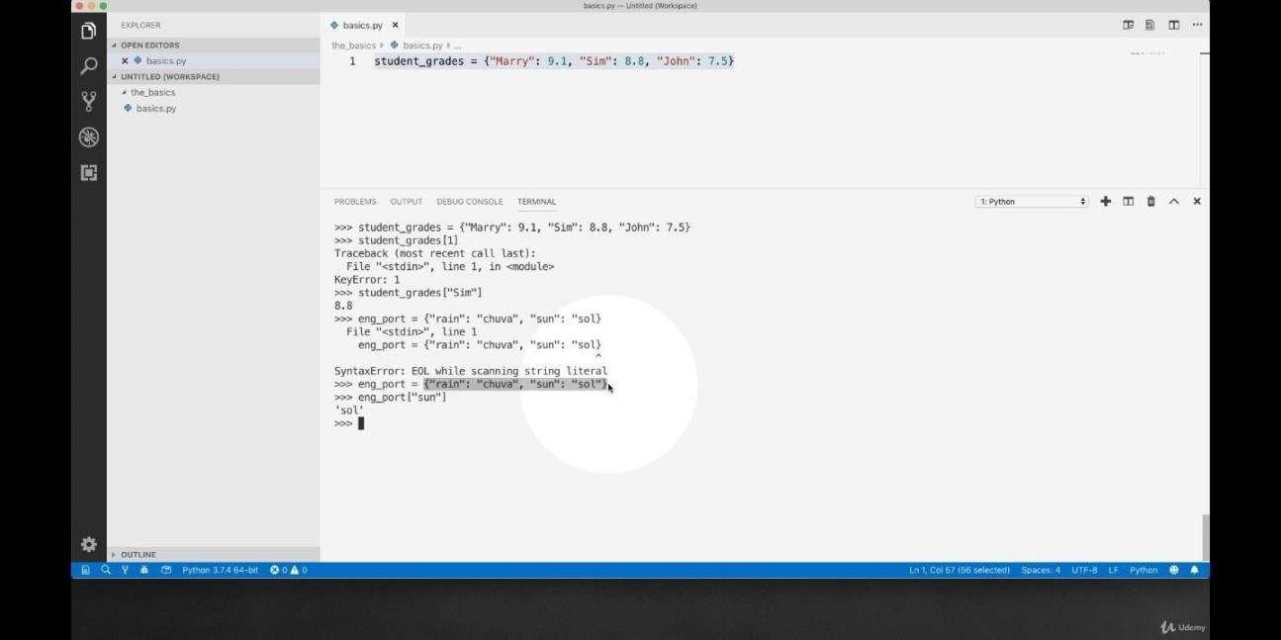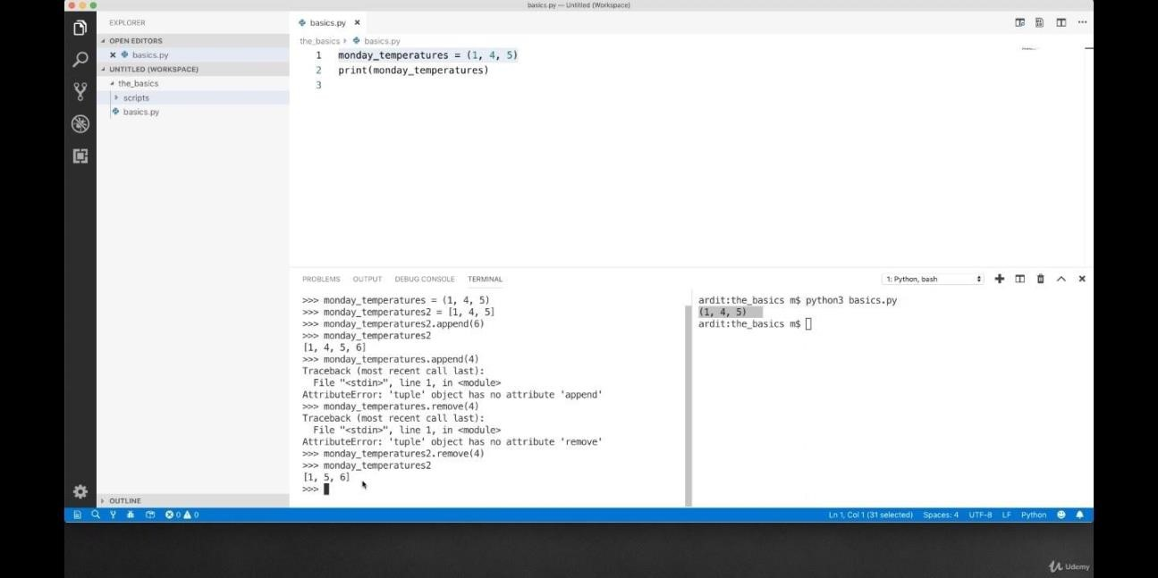

|  |
| --- |
| Report – Report can be typed or hand written for up to two pages.    LIST COMPREHENSION:-       * Python provides compact syntax for deriving one list from another. ● these expression are called list comprehension. * it is the most powerful tool in the python. * it is an eg for the languages support for functional programming concepts.       FUNCTIONS:-     * A function is a group of related statements that performs a specific task. ● it helps to break our program into smaller and modular chunks. * as our proggrams goes longer,functions makes it smaller. * it avoids repetition and makes the code reusable.       FILE PROCESSING:-       * working of open() function. ● working of read mode(). * creating a file using write() mode. * working of append() mode. * using write long with() function. * split() using file handling. |
|  |